Ideation Phase
Empathize & Discover

Team ID | NM2025TMID02656
Project Name | LAPTOP REQUEST CATALOG ITEM

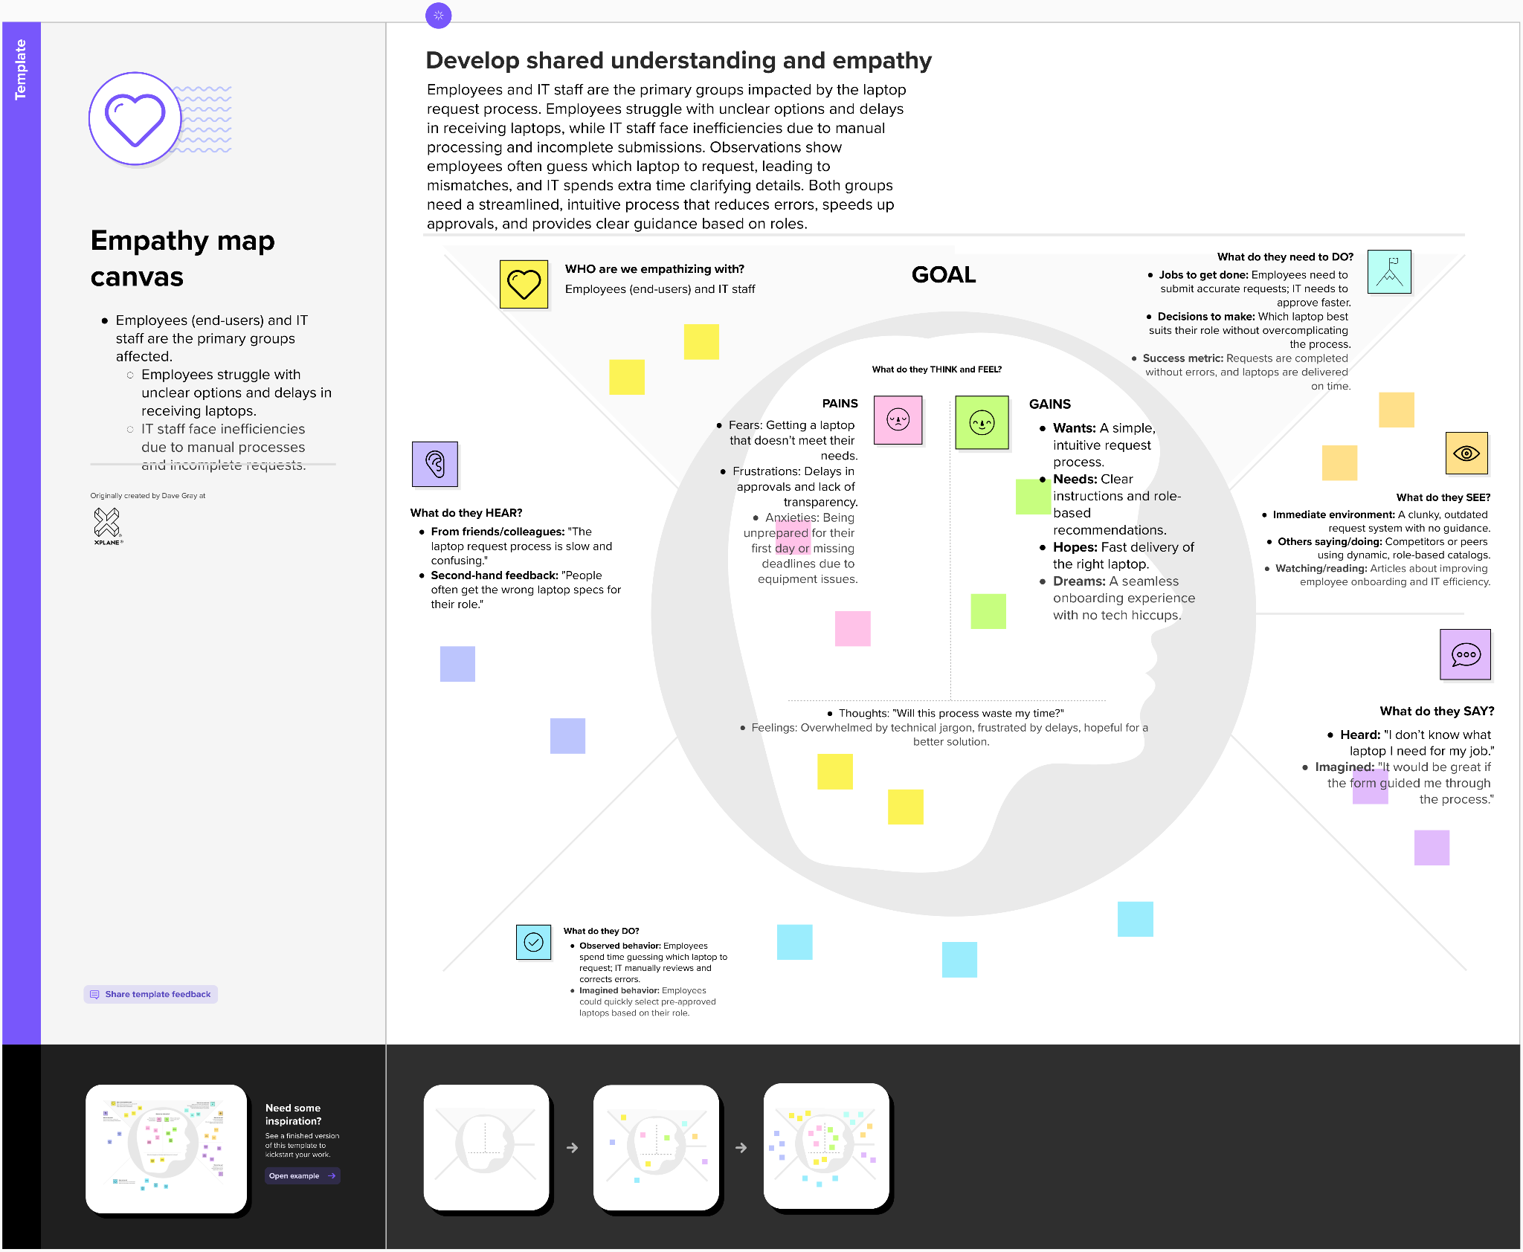
Empathy Map Canvas:

